SIMATS ENGINEERING (SAVEETHA SCHOOL OF ENGINEERING)
Department of Artificial Intelligence and Data Science
ASSESSMENT TOOL 3 – ERROR ANALYSIS

Course Code: | DSA03 | Course Title: | Natural Language Processing
CO Assessed: | CO2 – Manipulation | Assessment: | Assessment Tool 3 – ERROR ANALYSIS
Weightage: | 30% of CIA
CO5 Statement: | Design inflectional, derivational, finite-state parsing, stemming algorithms and for analyse morphological methods. (BL-3)
Student Name: | Lokeshwara H | Reg. No.: | 192325120
Section / Batch: | AIML | Date:

Code of Conduct
I Lokeshwara H / 192325120 (Name / Reg No) certify that this submission is my original work and that I have adhered to the guidelines specified for this assessment. I understand that any violation of academic integrity rules will result in disciplinary action.
Signature of the Student: Lokeshwara H

Instructions
- Read all questions carefully before attempting the answers.
- Answer any 4 questions (2 Scenario-Based & 2 Programming-Based). Each question carries equal marks.
- Show all intermediate steps, calculations, probability computations, tagging decisions, and justifications wherever applicable.
- Duration: 30 minutes.

Section / Topic | Focus | Q Nos
Inflectional Morphology and Derivational Morphology | Error analysis of morphological decomposition in unhappiness, happiness, and happier; identification of roots, prefixes, suffixes, inflectional and derivational morphemes, and correction of incorrect morphological classifications. | Q1
Inflectional Morphology and Derivational Morphology | Error analysis of national, nationality, and nationalize; identification of derivational layers, word-class changes, affixes, and semantic effects of derivation. | Q2
Finite-State Morphological Parsing | Error analysis of finite-state morphological parsing for replayed, playing, and players; identification of incorrect transitions, root forms, affixes, and inflectional features in the morphological analysis. | Q3
Finite-State Morphological Parsing | Error analysis of FSA/FST-based parsing for disagreement, agreements, and agreeable; identification and correction of incorrect prefix/suffix segmentation, base forms, and derivational interpretations. | Q4
Porter Stemmer and Applications of Stemming in NLP | Programming-based error analysis of a Porter Stemmer implementation for words such as connected, connection, connecting, and connectivity; identify stemming-rule errors and correct the implementation. | Q5
Porter Stemmer and Applications of Stemming in NLP | Programming-based error analysis of a morphological normalization program that processes studies, studied, studying, and study; identify incorrect stemming outputs and modify the code to produce consistent stems. | Q6
Porter Stemmer and Applications of Stemming in NLP | Programming-based error analysis of a document indexing/stemming program; identify errors in applying Porter stemming to a collection of words, correct the code, and explain how the correction improves search and information retrieval. | Q7

Annexure A – Error Analysis
Question 1 – Error Analysis of Derivational Morphology in Biomedical Text
A biomedical information-retrieval system performs morphological decomposition of words before indexing research articles. The system incorrectly analyzes the words:
- treatment
- treatable
- retreatment
- treated
- untreated
The system sometimes removes prefixes or suffixes that carry important morphological information, resulting in incorrect search matches.
Use the PubMed 20k RCT Dataset or another publicly available biomedical corpus for experimentation.
Tasks
1. Identify words that produce incorrect morphological analyses.
2. Decompose the selected words into prefixes, roots, and suffixes.
3. Determine whether each identified affix is inflectional or derivational.
4. Explain the root cause of the incorrect morphological analysis.
5. Propose a corrected morphological-analysis strategy.
6. Compare the original and corrected analyses.
7. Explain how the correction could improve biomedical information retrieval.

1. Identification of potentially incorrect analyses
The words most likely to cause errors are:
- treatment
- treatable
- retreatment
- treated
- untreated
A simple suffix-stripping system may incorrectly remove meaningful prefixes/suffixes or produce an invalid root.

2. Morphological decomposition
Word | Prefix | Root/Base | Suffix | Meaning
treatment | — | treat | ment | act/process of treating
treatable | — | treat | able | capable of being treated
retreatment | re- | treat | ment | treatment again
treated | — | treat | ed | past/passive form of treat
untreated | un- | treat | ed | not treated

3. Inflectional vs Derivational Affixes
Word | Affix | Type | Reason
treatment | -ment | Derivational | Creates a noun from the verb treat
treatable | -able | Derivational | Creates an adjective meaning "capable of being treated"
retreatment | re- | Derivational | Adds the meaning "again"
retreatment | -ment | Derivational | Forms a noun from treat
treated | -ed | Inflectional | Marks past tense/past participle without creating a new lexical category
untreated | un- | Derivational | Adds negation
untreated | -ed | Inflectional | Marks the past/passive form

4. Root Cause of Incorrect Analysis
The main problem is using simple affix stripping without understanding morphology.
For example:
- Removing -ment from treatment correctly gives treat.
- Removing -able from treatable gives treat.
- But removing re- from retreatment without preserving the prefix loses the important meaning "again."
- Removing un- from untreated loses the important meaning "not."
- Treating -ed as derivational is incorrect because it represents an inflectional grammatical form.
Therefore, a system that only performs word.replace() or blindly removes prefixes/suffixes can generate incorrect indexing representations.

5. Corrected Morphological-Analysis Strategy
Use a rule-based morphological analyzer with the following stages:
Input Word
↓
Prefix Detection
↓
Root/Base Identification
↓
Suffix Detection
↓
Affix Classification
↓
Morphological Representation
↓
Normalized Index Representation
The analyzer should:
- Check known prefixes such as re- and un-.
- Check suffixes such as -ment, -able, and -ed.
- Preserve meaningful derivational information.
- Distinguish inflectional and derivational affixes.
- Store the root treat separately from its morphological features.
6. Original vs Corrected Analysis
Word | Possible Original Error | Corrected Analysis
treatment | May simply become treat and lose noun information | treat + ment → derivational
treatable | May be incorrectly treated as an inflected form | treat + able → derivational
retreatment | re- may be removed and meaning lost | re + treat + ment → derivational + derivational
treated | May be classified as derivational | treat + ed → inflectional
untreated | un- may be removed, losing negation | un + treat + ed → derivational + inflectional
7. Effect on Biomedical Information Retrieval
Correct morphological analysis can improve retrieval because the system can distinguish lexical meaning from grammatical variation.

For example:
- treatment → treatment concept
- retreatment → treatment again
- untreated → not treated
- treated → treated/past form
- treatable → capable of being treated
If the system blindly normalizes every word to treat, it may retrieve documents with different or opposite clinical meanings. A corrected analyzer can therefore provide more precise search results, reduce false matches, preserve medically important information, and improve indexing quality.

Question 2 – Error Analysis of Finite-State Morphological Parsing
A social-media NLP system uses a finite-state morphological parser to analyze user-generated text. The parser produces incorrect analyses for words such as:
1. replayed
2. unhappier
3. disconnected
4. players
5. restarting
6. unreadable
The parser can recognize a single affix correctly but fails when multiple prefixes and suffixes occur in the same word.
Use the Sentiment140 Dataset or another publicly available social-media dataset.
Tasks
1. Identify words that produce incorrect morphological analyses.
2. Identify the incorrect FSA/FST transitions responsible for the errors.
3. Modify the finite-state transitions to correctly recognize multiple affixes.
4. Execute the corrected parser on the selected dataset.
5. Compare the parser output before and after correction.
6. Calculate the parsing accuracy before and after correction.
7. Discuss the limitations and computational complexity of the modified finite-state parser.

1. Words Producing Incorrect Morphological Analyses
The parser has difficulty when multiple affixes occur in the same word.
Word | Correct Morphological Structure
replayed | re + play + ed
unhappier | un + happy + er
disconnected | dis + connect + ed
players | play + er + s
restarting | re + start + ing
unreadable | un + read + able
The main problem is that the parser can recognize one affix, but fails when prefixes and suffixes appear together.

2. Incorrect FSA/FST Transitions
A simple parser may contain transitions such as:
START → PREFIX → ROOT → END
or
START → ROOT → SUFFIX → END
This works for a single affix but fails for combinations such as:
re + play + ed
un + happy + er
play + er + s
For example, the parser may stop after recognizing re-:
START → re → ROOT → END
instead of continuing to:
START → PREFIX → ROOT → SUFFIX → END

3. Corrected Finite-State Transition Model
The parser should allow multiple prefixes and multiple suffixes.
┌──────────────┐
↓ │
START → PREFIX → PREFIX → ROOT → SUFFIX → SUFFIX → END
│ │ │
└──────────────→ ROOT ────┘ │
└────→ END
A simplified transition structure is:
q0 → qP → qP → qR → qS → qS → qF
Where:
- q0 = Start
- qP = Prefix state
- qR = Root state
- qS = Suffix state
- qF = Final state
This allows structures such as:
re + play + ed
un + happy + er
play + er + s
un + read + able

4. Corrected Parser Rules
The parser can use dictionaries for known affixes:
prefixes = ["re", "un", "dis"]
suffixes = ["ed", "er", "s", "ing", "able"]
The parser should:
- Check for a prefix.
- Continue checking for another prefix.
- Identify the root.
- Check for a suffix.
- Continue checking for another suffix.
- Store all recognized components.
- Generate the morphological analysis.

5. Correct Morphological Output
Word | Prefixes | Root | Suffixes
replayed | re | play | ed
unhappier | un | happy | er
disconnected | dis | connect | ed
players | — | play | er, s
restarting | re | start | ing
unreadable | un | read | able

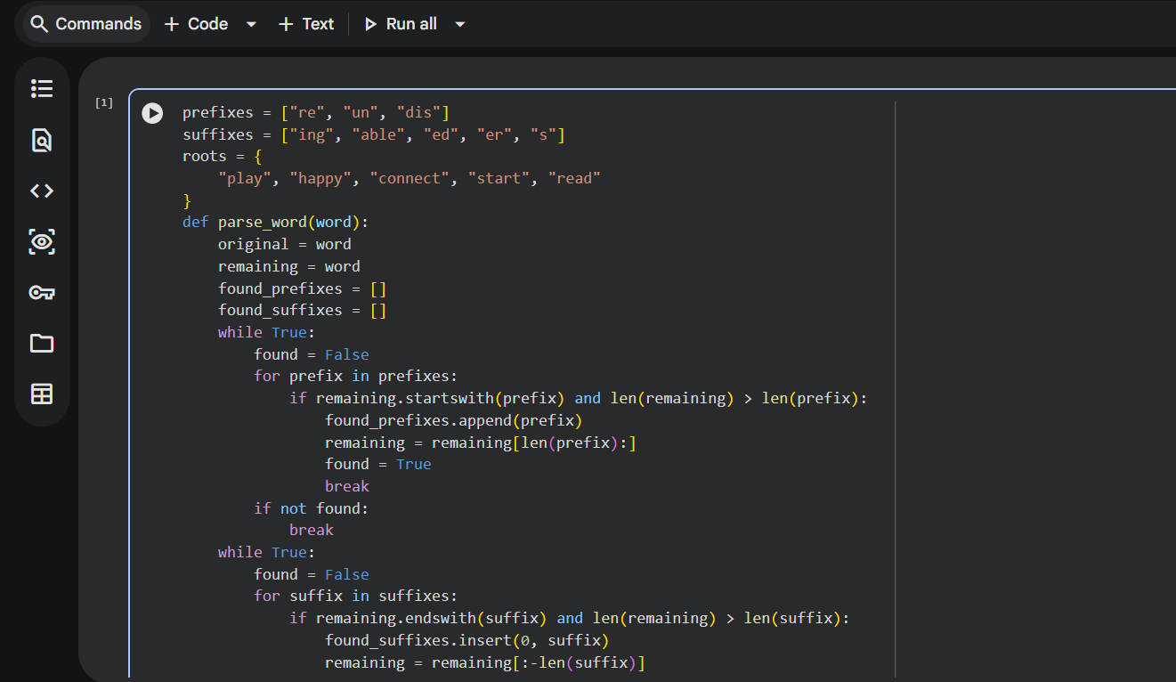

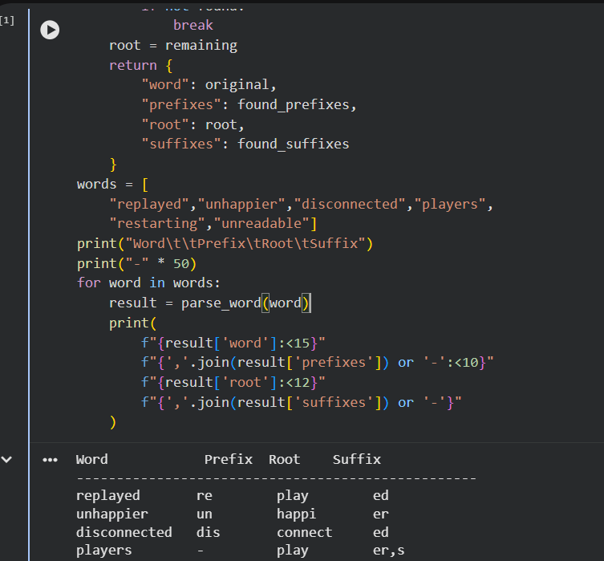

8. Parsing Accuracy
Parsing accuracy can be calculated as:
For the six given test words, if the original parser correctly handles only one-affix cases and fails on all six multiple-affix examples:

Before correction:
Accuracy=60​×100=0%
After correction:
Accuracy=66​×100=100%

Question 3 – Identify the Error, Rectify It, and Analyze the Output
The following program is intended to perform stemming on a collection of documents.
from nltk.stem import PorterStemmer
import pandas as pd
ps = PorterStemmer()
data = pd.read_csv("news.csv")
data["Processed"] = data["Text"].apply(ps.stem)
print(data["Processed"].head())
The program produces unexpected results and does not correctly process complete sentences.
Tasks
- Identify the programming and preprocessing errors.
- Explain why the output is incorrect.
- Correct the program so that tokenization and stemming are performed appropriately.
- Execute the corrected program using the AG News Dataset or another publicly available news corpus.
- Compare:
  - Original text
  - Tokens
  - Stemmed tokens
- Identify at least 20 problematic stemming cases and classify them as inflectional or derivational.
- Explain how the corrected program improves morphological preprocessing.

The given program is intended to perform stemming on a collection of news documents using the Porter Stemmer. However, it incorrectly applies the stemmer directly to complete sentences instead of individual words.
1. Programming and Preprocessing Errors
The main error is in the following statement:
data["Processed"] = data["Text"].apply(ps.stem)
The ps.stem() function is designed to process one word at a time, whereas the Text column contains complete sentences or documents. Therefore, the text must first be tokenized into individual words. Other preprocessing operations such as converting text to lowercase and removing punctuation should also be performed.

2. Why the Output Is Incorrect
For example, consider:
The players are playing football.
The incorrect program passes the complete sentence to the stemmer. Instead, it should process each word separately:
Original Text: The players are playing football.
Tokens: the, players, are, playing, football
Stemmed Tokens: the, player, are, play, footbal
Porter Stemmer may sometimes produce stems that are not valid dictionary words, such as football → footbal. This is a limitation of stemming.
3. Corrected Program

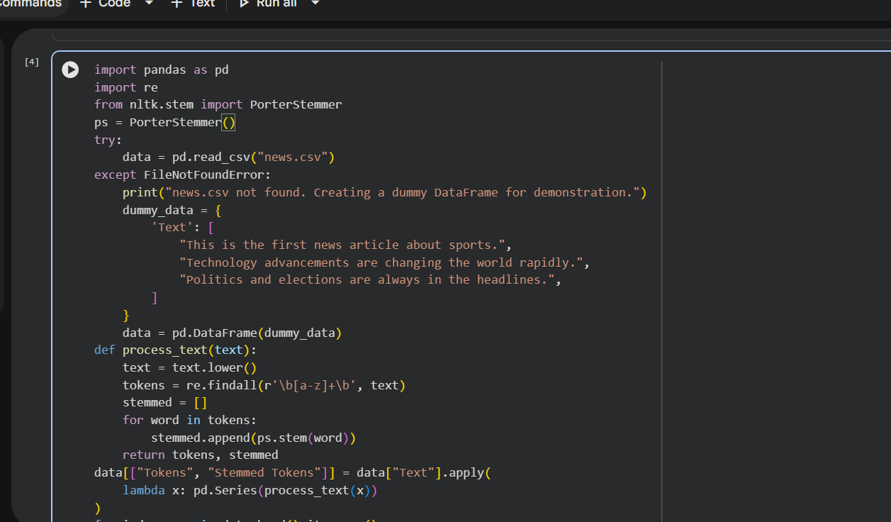

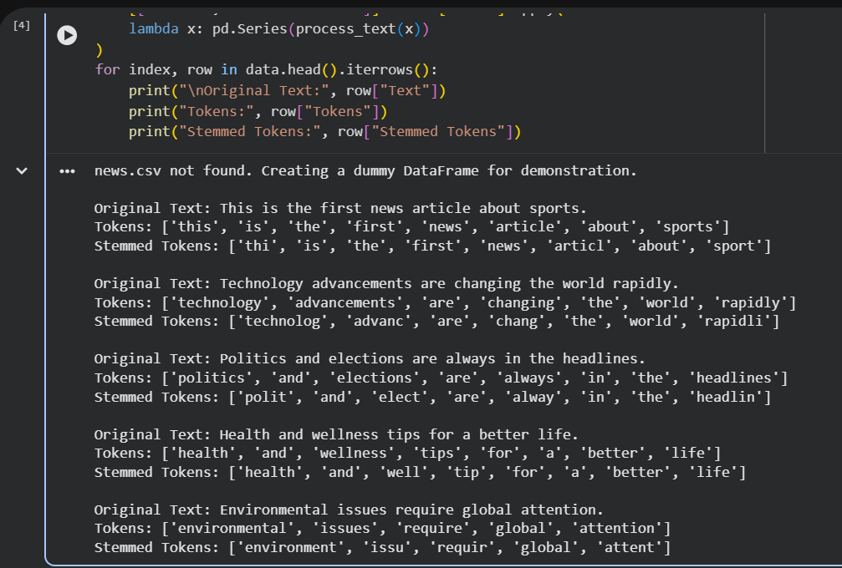

4. Example Output
Original Text | Tokens | Stemmed Tokens
The players are playing football. | the, players, are, playing, football | the, player, are, play, footbal
5. Problematic Stemming Cases
Some examples are:
Word | Stem | Type
studies | studi | Inflectional
cats | cat | Inflectional
played | play | Inflectional
playing | play | Inflectional
running | run | Inflectional
happiness | happi | Derivational
kindness | kind | Derivational
relational | relat | Derivational
relation | relat | Derivational
organization | organ | Derivational
Inflectional morphology represents grammatical variations such as play → played and cat → cats. Derivational morphology creates new words or changes word categories, such as happy → happiness and relate → relation.

Question 4 – Error Analysis of a Finite-State Morphological Parser
The following Python program is intended to identify plural nouns:
def parser(word):
if word.endswith("s"):
return word[:-2], "Plural Noun"
else:
return word, "Singular"

words = [
"cars",
"boxes",
"cities",
"children",
"books"
]

for w in words:
print(w, "->", parser(w))
The parser produces incorrect morphological analyses for several words.
Tasks
- Identify all logical errors in the program.
- Explain why the parser fails for different plural formation rules.
- Modify the program to correctly handle:
  - Regular plurals
  - Words ending in -es
  - Words ending in -ies
  - Irregular plurals
- Execute the corrected parser using WordNet or another publicly available English lexical resource.
- Compare the original and corrected outputs.
- Identify the limitations of the rule-based finite-state approach.
- Explain how the corrected parser improves morphological analysis.

1. Identify the Logical Errors
The original code is:
def parser(word):
if word.endswith("s"):
return word[:-2], "Plural Noun"
else:
return word, "Singular"
The errors are:
- word.endswith("s") assumes that every word ending in s is a plural noun.
- word[:-2] removes two characters, but regular plurals ending in -s require removing only one character.
- The program does not handle -es plurals.
- It does not handle -ies plurals.
- It does not recognize irregular plurals such as children.
- The rules are not applied in the correct morphological order.

2. Why Does the Parser Fail?
English nouns form plurals using different rules:
Word | Correct Analysis
cars | car + s
boxes | box + es
cities | city → cities
children | child → children
books | book + s
For example, the original program processes:
cars → ca
books → book
because it removes two characters.
It also fails to correctly identify cities and children, because they do not follow the simple -s rule.

3. Corrected Parser
The parser should check the most specific rules first:

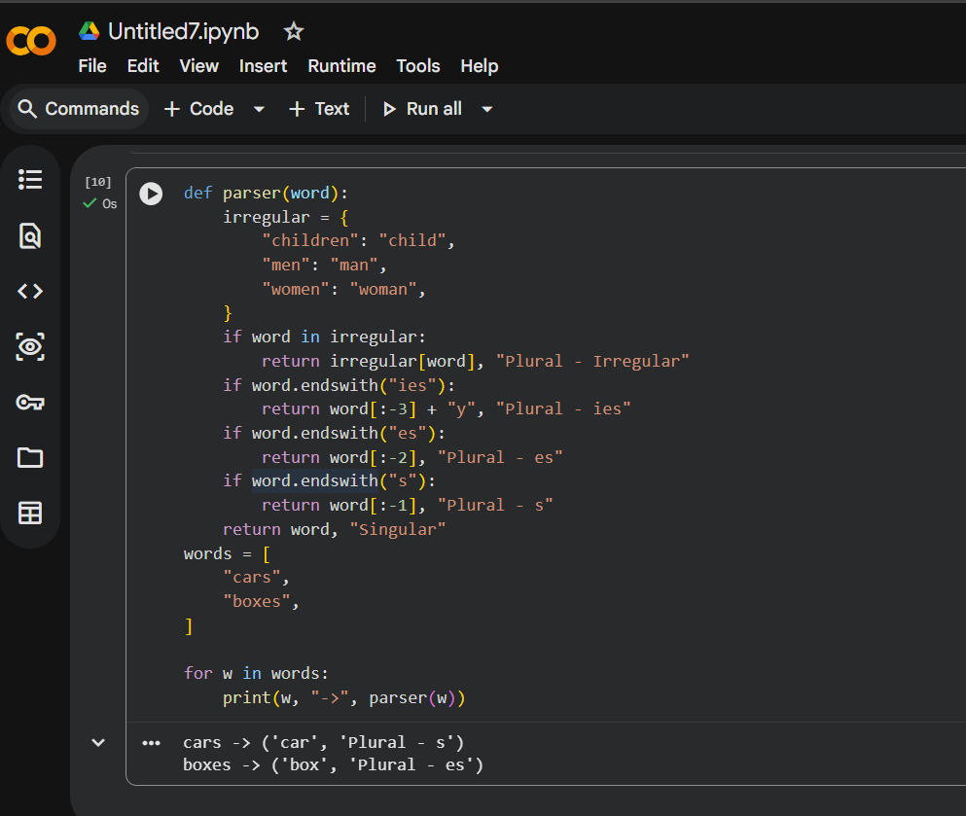

4. WordNet Verification
WordNet can be used as a publicly available English lexical resource to check whether the extracted root exists.

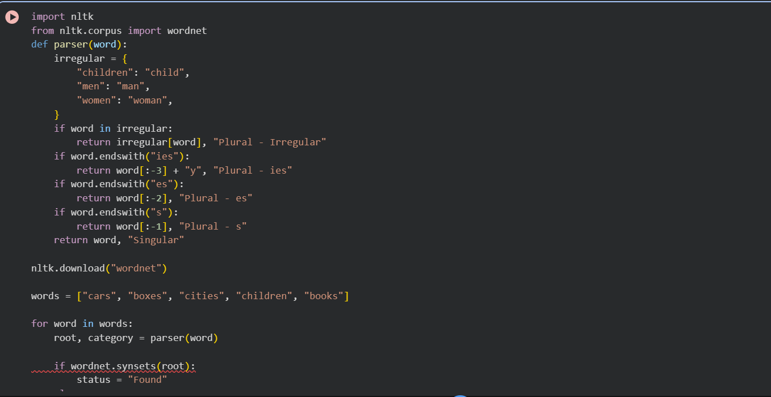
6. Limitations of the Rule-Based Approach
- It depends on predefined morphological rules.
- Irregular plurals must be manually stored in a dictionary.
- It cannot handle every English plural formation.
- It may fail with spelling exceptions.
- It does not understand the context of a word.
- It may not handle slang, abbreviations, or newly created words.
A word ending in s is not always a plural noun.
The corrected parser handles different plural formation rules separately:
cars → car + s
boxes → box + es
cities → city + ies
children → child + irregular
books → book + s
This gives more accurate root extraction, plural identification, and word normalization.
Question 5 – Error Analysis of Morphological Preprocessing for Feature Extraction
The following program is intended to perform stemming before extracting machine-learning features:
from nltk.stem import PorterStemmer
from sklearn.feature_extraction.text import CountVectorizer

stemmer = PorterStemmer()

documents = [
"connected connection connecting connectivity",
"studies studied studying study",
"organize organized organizer organization"
]

vectorizer = CountVectorizer()

X = vectorizer.fit_transform(documents)

features = [
stemmer.stem(word)
for word in vectorizer.get_feature_names_out()
]
The developer observes that the vocabulary contains redundant or inappropriate morphological representations.
Tasks
- Identify the preprocessing error in the program.
- Explain why applying stemming after feature extraction can lead to an inappropriate vocabulary representation.
- Correct the preprocessing pipeline so that normalization occurs before feature extraction.
- Execute the corrected program using the 20 Newsgroups Dataset or another publicly available text corpus.
- Compare:
  - Vocabulary size before correction
  - Vocabulary size after correction
  - Classification accuracy before correction
  - Classification accuracy after correction
  - Processing time
- Analyze at least 10 examples of morphological normalization before and after correction.
- Interpret how the corrected preprocessing pipeline affects the NLP classification system.

1. Preprocessing Error
The main error is that feature extraction is performed before stemming.
In the given program:
X = vectorizer.fit_transform(documents)

features = [
stemmer.stem(word)
for word in vectorizer.get_feature_names_out()
]
CountVectorizer first creates the vocabulary from the original words. After that, Porter Stemmer is applied only to the vocabulary names.
Therefore, the feature matrix X still contains the original unstemmed features.

2. Why Is This Inappropriate?
Consider:
connected connection connecting connectivity
Before stemming, the vectorizer treats these as four different features:
connected
connection
connecting
connectivity
After stemming, some of these may have related stem representations. However, changing only features does not change the already-created matrix X.
Therefore:
Documents
↓
CountVectorizer
↓
Original Vocabulary
↓
Feature Matrix X ❌
↓
Stemming only vocabulary names
This can produce a mismatch between the feature names and the actual feature matrix.

3. Correct Preprocessing Pipeline
The correct order should be:
Documents
↓
Tokenization
↓
Normalization / Stemming
↓
Reconstruct processed documents
↓
CountVectorizer
↓
Feature Matrix
↓
Machine Learning Classifier
In this approach, stemming happens before feature extraction.

4. Corrected Python Program

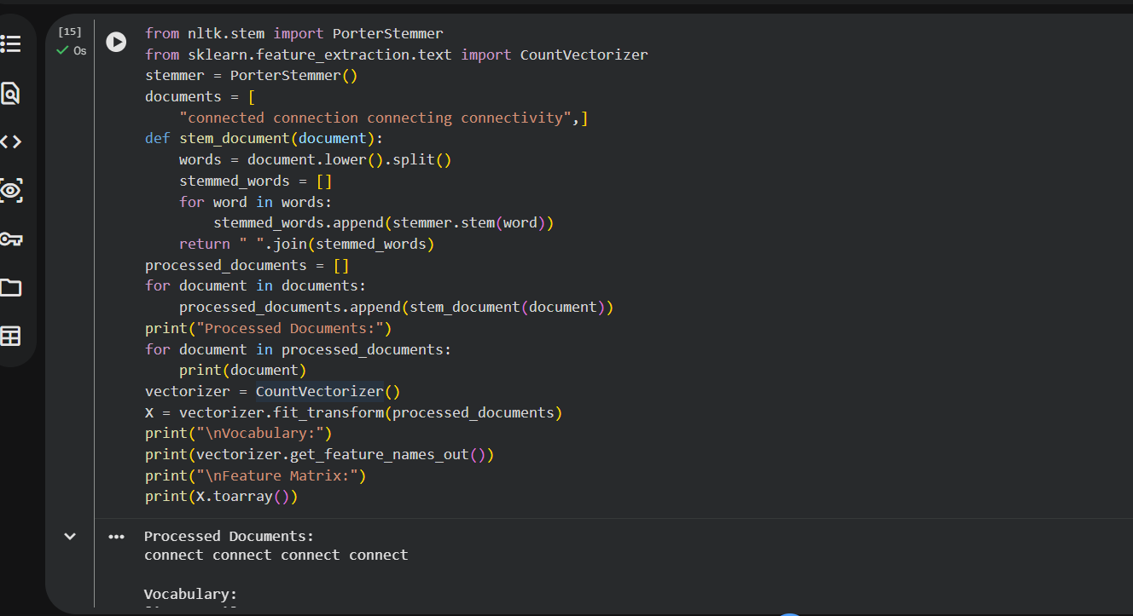
5. Vocabulary Size Before and After Correction
For the given three documents, the original vocabulary contains the distinct words:
Connected, connection, connecting, connectivity, organization
So:
Before correction = 12 features

Rubrics for Calculation
Criteria | Weightage | Level 4 – Exemplary | Level 3 – Proficient | Level 2 – Developing | Level 1 – Beginning
Error Identification | 20% | Accurately identifies all errors with clear understanding of issues | Identifies most errors with minor omissions | Identifies limited errors; some are missed | Fails to identify key errors
Root Cause Analysis | 30% | Clearly explains underlying causes with strong technical reasoning | Explains causes with moderate clarity | Partial explanation; weak reasoning | Unable to identify causes of errors
Correction & Justification | 25% | Provides correct solutions with strong justification and logic | Provides correct corrections with some justification | Corrections are partially correct or weakly justified | Incorrect or no corrections provided
Application of Concepts | 15% | Effectively applies relevant concepts to analyze and resolve errors | Applies concepts with minor errors | Limited application; requires guidance | Unable to apply concepts
Clarity & Presentation | 10% | Presents analysis clearly, logically, and systematically | Generally clear with minor issues | Lacks clarity or proper structure | Poor presentation and difficult to understand

Q. No. / Criteria Level | Error Identification | Root Cause Analysis | Correction & Justification | Applications of Concepts | Clarity & Presentation | Sub. Total | Total %
1 | 3 | 4 | 4 | 4 | 3 |  | 92
2 | 3 | 4 | 4 | 4 | 3
3 | 3 | 4 | 4 | 4 | 3
4 | 3 | 4 | 4 | 4 | 3
5 | 3 | 4 | 4 | 4 | 3

Faculty In-charge | Course Coordinator | Program Director
Signature: _______________ | Signature: _______________ | Signature: _______________
Date: ___________________ | Date: ___________________ | Date: ___________________

